AWS Cost Optimization
1. Introduction
AWS Cost Optimization means running your workloads at the lowest possible cost while still meeting performance, availability, and security requirements.
It is one of the five pillars of the AWS Well-Architected Framework.

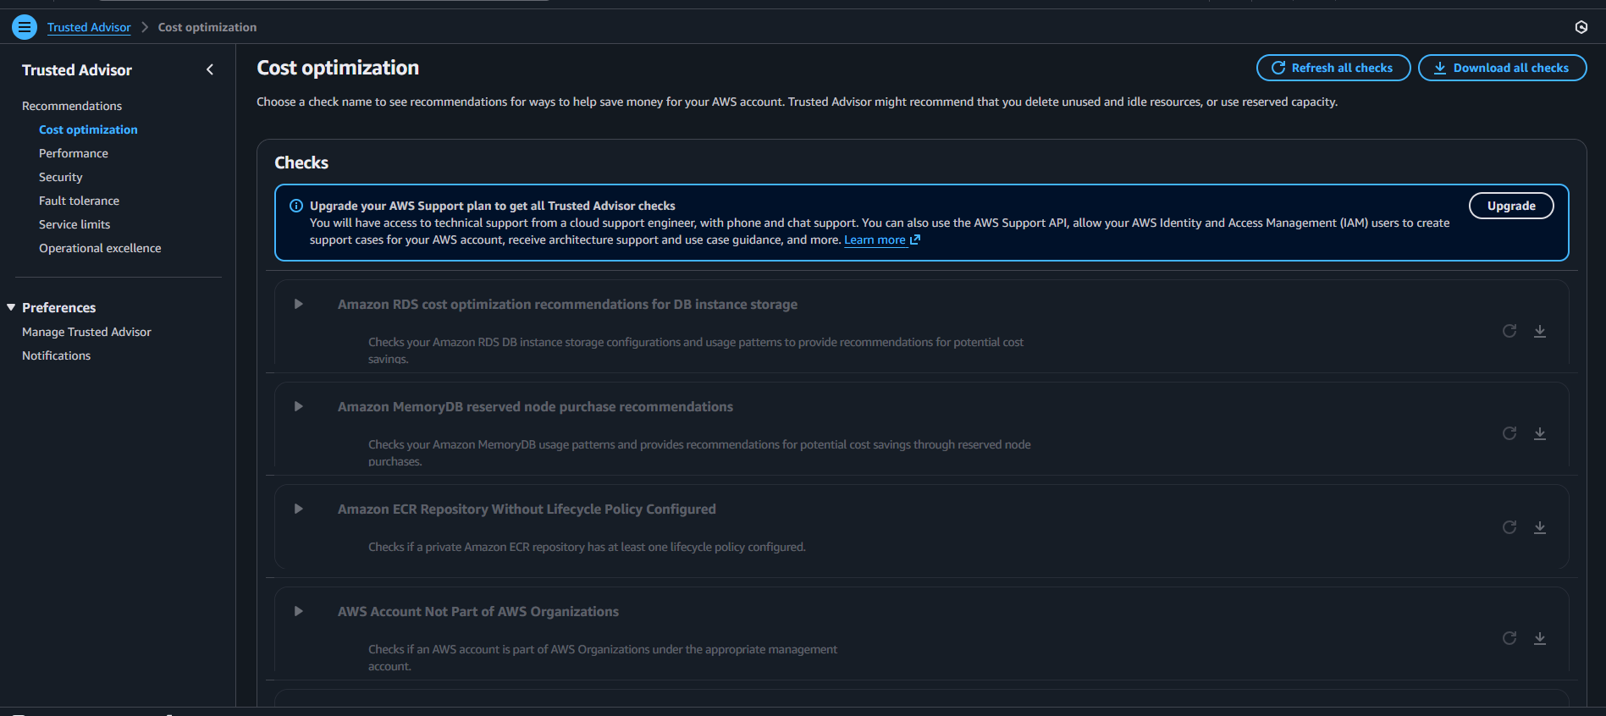
2. How Cost Optimization Works (Overall Flow)
- Measure – Track usage and spending (Monitoring & Billing)
- Right-size – Use correct resource sizes (EC2, RDS)
- Scale dynamically – Scale only when needed (Auto Scaling)
- Use managed and serverless services where possible
- Optimize data transfer and storage
- Continuously review and improve
Cost Optimization by AWS Service (Detailed)

3.1 Amazon EC2 – Elastic Compute Cloud
How EC2 Costs Are Incurred
- Instance hours (On-Demand / Reserved / Spot)
- Storage (EBS)
- Data transfer
- Idle instances
Cost Optimization Techniques
1) Right-sizing
- Use CloudWatch metrics to downsize overpowered instances
- Example: t3.large → t3.micro
2) Instance Purchasing Options
- On-Demand: Short-term and unpredictable workloads
- Reserved Instances (RI): 1–3 year steady workloads (up to 72% savings)
- Savings Plans: Flexible compute savings
- Spot Instances: Up to 90% cheaper for fault-tolerant workloads
3) Stop / Terminate Idle EC2
- Stop non-production EC2 during nights and weekends
- Terminate unused test instances
4) Use Auto Scaling
- Use Auto Scaling instead of fixed EC2 to reduce idle compute cost

3.2 Amazon VPC – Virtual Private Cloud
What Costs Money in VPC
- NAT Gateway (major cost)
- VPC endpoints
- Data transfer between Availability Zones
- Elastic IPs (when unused)
Cost Optimization Techniques
1) Reduce NAT Gateway Costs
- Use one NAT Gateway per AZ only if required
- Route traffic carefully
- Use VPC Endpoints for S3 and DynamoDB to reduce NAT cost
2) Avoid Cross-AZ Traffic
- Keep ALB → EC2 → RDS in the same Availability Zone when possible
3) Release Unused Elastic IPs
- Remove unused Elastic IPs to avoid unnecessary charges

3.3 AWS IAM – Identity and Access Management
IAM Cost
- IAM is free
Cost Optimization Role
Although IAM is free, it prevents cost leaks by controlling access.
1) Enforce Least Privilege
- Prevent users from launching large EC2 or RDS instances accidentally
2) Use IAM Roles Instead of Access Keys
- Reduces misuse and security breaches that can cause unexpected billing

3.4 Amazon S3 – Simple Storage Service
How S3 Costs Are Incurred
- Storage size
- Storage class
- Requests
- Data transfer out
Cost Optimization Techniques
1) Choose the Correct Storage Class
- S3 Standard: Frequent access
- S3 Standard-IA: Infrequent access
- Glacier / Deep Archive: Long-term backups (very low cost)
2) Lifecycle Policies
- Move old data automatically to cheaper storage classes
- Delete unnecessary objects
3) Enable Compression
- Reduce object size to lower storage and data transfer cost

3.5 Amazon Route 53 – DNS
How Route 53 Costs Are Incurred
- Hosted zones
- DNS queries
- Health checks
Cost Optimization Techniques
- Use simple routing when advanced routing is not required
- Avoid unnecessary health checks
- Use CloudFront with Route 53 to reduce repeated lookups

3.6 Amazon CloudFront – CDN
Why CloudFront Reduces Cost
CloudFront caches content closer to users and reduces load on:
- EC2
- ALB
- RDS
Cost Optimization Techniques
- Enable caching for static content
- Enable compression (Gzip)
- Reduce origin requests
- Use CloudFront Price Class if global access is not required

3.7 Amazon CloudWatch – Monitoring
Monitoring Costs
- Custom metrics
- Logs storage
- Alarms
Cost Optimization Techniques
- Use basic metrics where possible
- Set log retention policies (example: 7–30 days)
- Create alarms to detect idle resources and cost spikes
Monitoring helps identify waste early.

3.8 Auto Scaling Group (ASG)
Why ASG is Critical for Cost Optimization
- Scales out during traffic spikes
- Scales in when traffic drops
Cost Benefits
- Prevents idle EC2 instances
- Pay only for resources you use
- Can be combined with Spot Instances for maximum savings

3.9 Application Load Balancer (ALB)
How ALB Costs Are Incurred
- Load balancer hours
- LCU usage (requests, connections, data)
Cost Optimization Techniques
- Use one ALB per application to avoid unnecessary duplication
- Combine multiple services using path-based routing
Example:
- /api
- /images
- /admin

3.10 Amazon RDS – Relational Database Service
How RDS Costs Are Incurred
- Instance size
- Storage
- IOPS
- Backups
Cost Optimization Techniques
1) Right-size RDS
- Avoid overprovisioning CPU and RAM
2) Reserved Instances
- Best for long-term databases and provides major savings
3) Storage Optimization
- Use GP3 instead of GP2
- Enable storage autoscaling
4) Stop RDS (Non-Production)
- Stop dev and test databases when not in use

3.11 AWS KMS – Key Management Service
What Costs Money in KMS
- Customer-managed keys (monthly cost per key)
- API requests (Encrypt, Decrypt, GenerateDataKey)
- Cross-region key usage
Cost Optimization Techniques
1) Use AWS-Managed Keys Where Possible
- AWS-managed keys are free
- Use customer-managed keys only when compliance requires it
2) Reduce KMS API Calls
- Cache decrypted data keys in applications
- Avoid encrypt and decrypt operations in tight loops
3) Reuse Keys
- Avoid creating multiple keys for the same workload
4) Delete Unused Keys
- Schedule deletion for unused customer-managed keys
Why KMS Optimization Matters
KMS cost scales with API usage and poor design creates hidden recurring costs.

3.12 Amazon MQ
What Costs Money in Amazon MQ
- Broker instance hours
- Storage
- Data transfer
- Multi-AZ deployment
Cost Optimization Techniques
1) Choose Correct Broker Size
- Do not over-provision CPU and memory
2) Use Single Instance if HA is Not Required
- Multi-AZ doubles the cost
- Use Multi-AZ only for mission-critical systems
3) Delete Idle Brokers
- Brokers keep billing even when idle
4) Prefer SQS When Possible
Use MQ only when:
- ActiveMQ or RabbitMQ compatibility is needed
- Legacy messaging is required
Key insight:
- Amazon MQ = higher control, higher cost
- Amazon SQS = serverless, low cost

3.13 Amazon SQS – Simple Queue Service
What Costs Money in SQS
- Number of requests
- Payload size
- FIFO queues cost more than Standard queues
Cost Optimization Techniques
1) Use Standard Queue Instead of FIFO
- Use FIFO only when ordering and exactly-once processing is required
2) Batch Messages
- Send and receive messages in batches (up to 10)
- Reduces API calls and lowers cost
3) Optimize Message Size
- Compress payloads
- Store large data in S3 and send only the S3 link
4) Set Correct Retention Period
- Avoid long retention unless required
Why SQS is Cost-Efficient
- Fully serverless
- Pay only per request
- No idle cost

3.14 Amazon API Gateway
What Costs Money in API Gateway
- Number of API calls
- Data transfer
- Cache usage
Cost Optimization Techniques
1) Enable API Caching
- Reduces backend calls to Lambda and EC2
- Best for read-heavy APIs
2) Use HTTP APIs Instead of REST APIs
- HTTP APIs are cheaper
- Use REST APIs only if advanced features are required
3) Throttle Requests
- Prevent abuse and avoid cost spikes
4) Combine Endpoints
- Reduce the number of APIs deployed
Key Tip
API Gateway cost is traffic driven. Optimize by reducing backend hits, not only API calls.

3.15 AWS Secrets Manager
What Costs Money in Secrets Manager
- Secrets stored (monthly cost per secret)
- API calls
- Automatic rotation
Cost Optimization Techniques
1) Store Only Required Secrets
- Delete unused secrets
2) Avoid Frequent Secret Reads
- Cache secrets inside the application memory
3) Use Parameter Store (Standard) When Possible
- For non-rotating and non-sensitive values
- Parameter Store Standard is free
4) Rotate Only Critical Secrets
- Rotation uses Lambda and increases cost

4. Conclusion
AWS Cost Optimization ensures that cloud resources are used efficiently by reducing waste and controlling unnecessary spending.
By implementing right-sizing, dynamic scaling, efficient purchasing options, data optimization, and continuous monitoring, organizations can meet performance requirements while keeping AWS costs under control.

